S.K.LOHIT DEVESHAWAR

192211054

USE CASE DIAGRAMS

1.ONLINE VOTING SYSTEM:

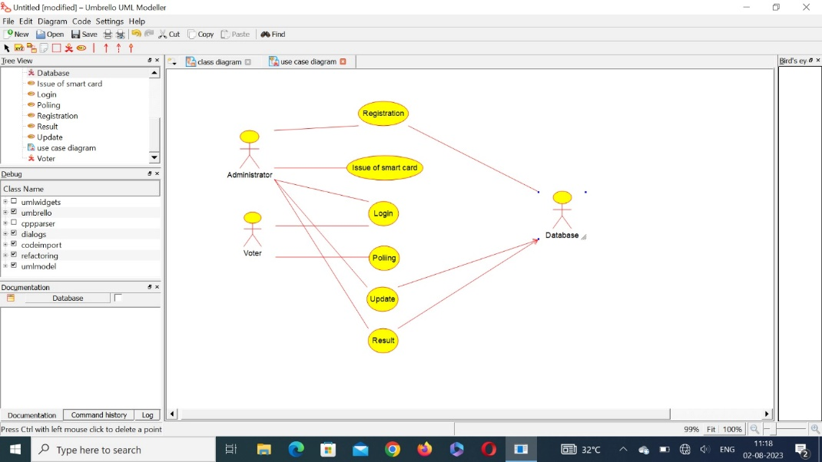

2.ONLINE LIBRARY MANAGEMENT:

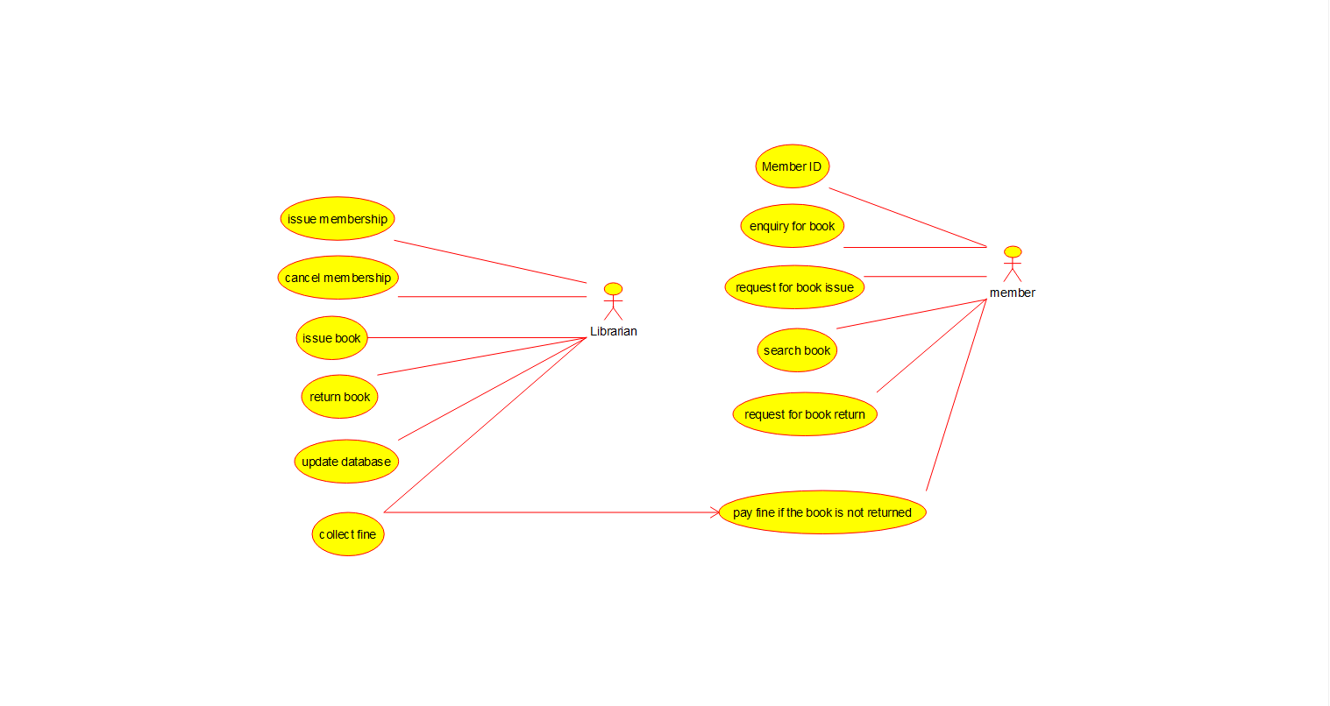

3.ONLINE SHOPPING SYSTEM:

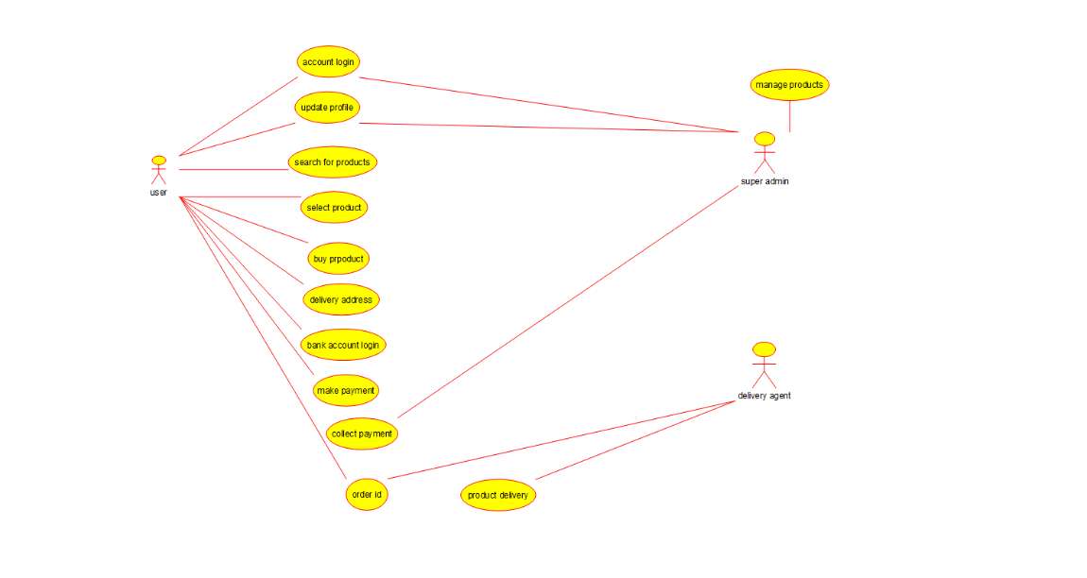

4.ONLINE RAILWAY RESERVATION:

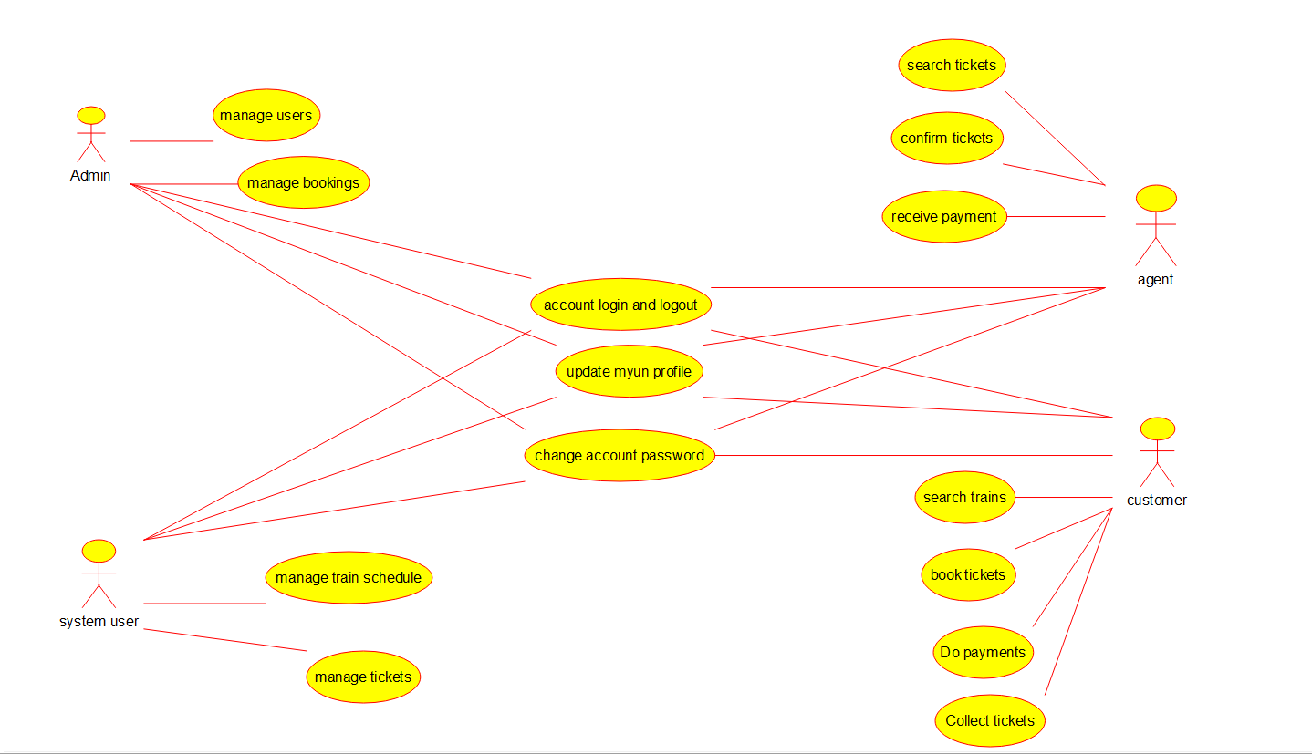

5.HOSPITAL MANAGEMENT:

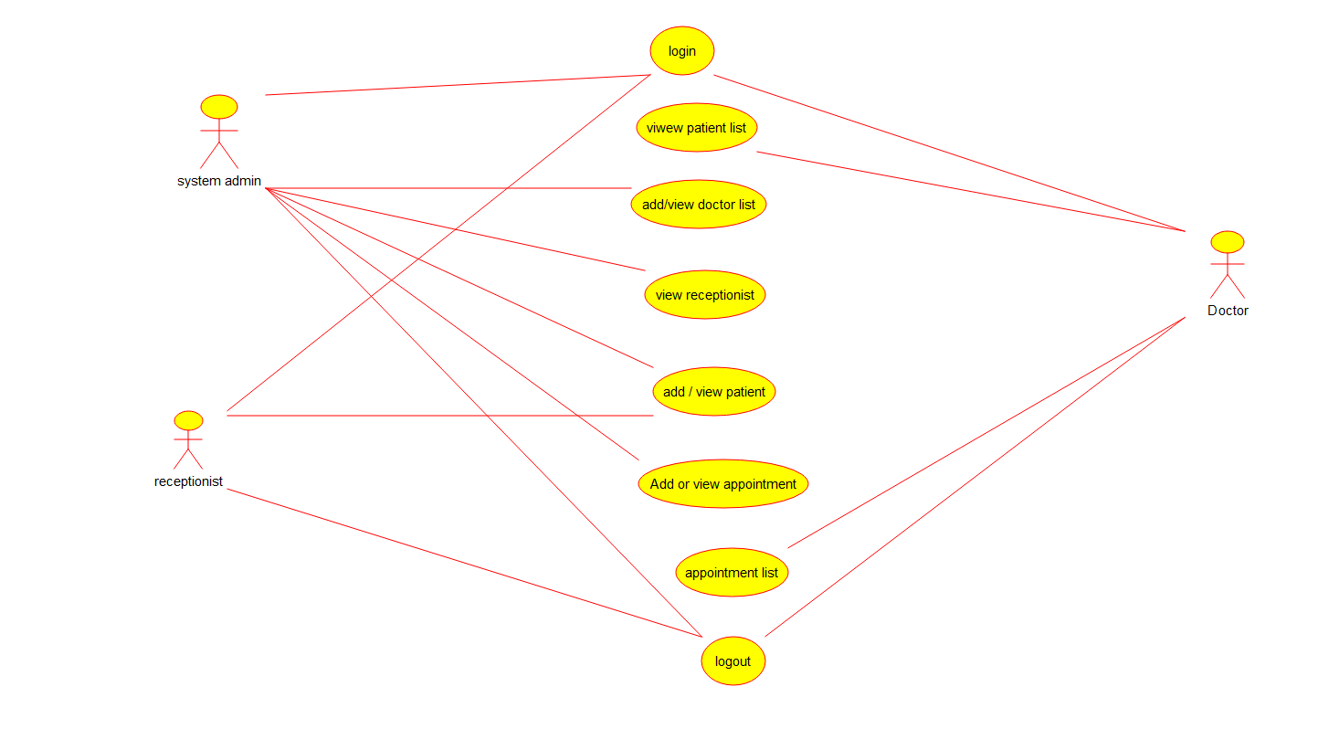

6.ATM MANAGEMENT:

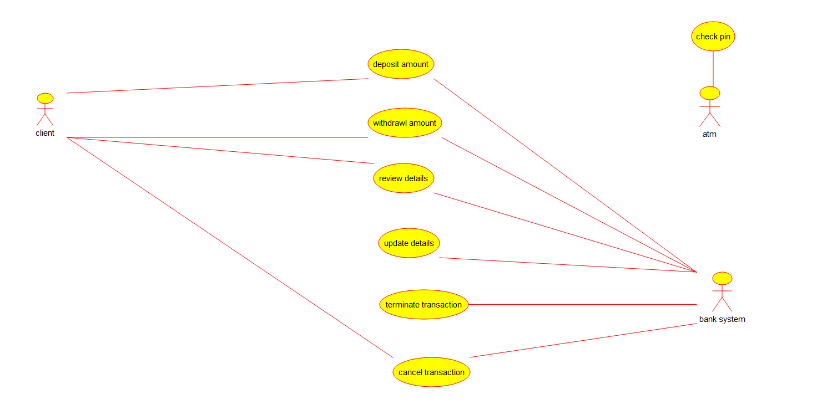

7.COLLEGE MANAGEMENT SYSTEM:

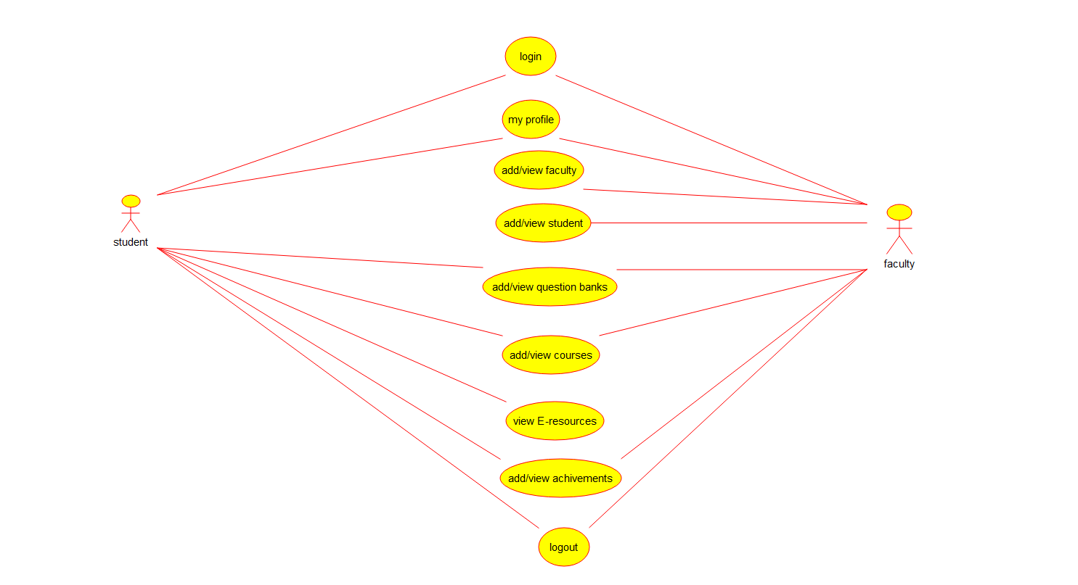

8.ONLINE AIRLINE RESERVATION SYSTEM:

